NAME: MAQSOOD AHMED
ID: 38186
DEPT: BSCS
PF_TASK: 08

Source Code:

#include <iostream>
using namespace std;

const int clubs = 0;
const int diamonds = 1;
const int hearts = 2;
const int spades = 3;

const int jack = 11;
const int queen = 12;
const int king = 13;
const int ace = 14;

struct card {
int number;
int suit;
};

int main() {
card temp, chosen, prize;
int position;

card card1 = { 7, clubs };
cout << "Card 1 is the 7 of clubs\n";
card card2 = { jack, hearts };
cout << "Card 2 is the jack of hearts\n";
card card3 = { ace, spades };
cout << "Card 3 is the ace of spades\n";

prize = card3;

cout << "I’m swapping card 1 and card 3\n";
temp = card3; card3 = card1; card1 = temp;

cout << "I’m swapping card 2 and card 3\n";
temp = card3; card3 = card2; card2 = temp;

cout << "I’m swapping card 1 and card 2\n";
temp = card2; card2 = card1; card1 = temp;

cout << "Now, where (1, 2, or 3) is the ace of spades? ";
cin >> position;

switch (position) {
case 1: chosen = card1; break;
case 2: chosen = card2; break;
case 3: chosen = card3; break;
}

if (chosen.number == prize.number && chosen.suit == prize.suit) {
cout << "That’s right! You win!\n";
} else {
cout << "Sorry. You lose.\n";
}

return EXIT_SUCCESS;
}

OUTPUT:

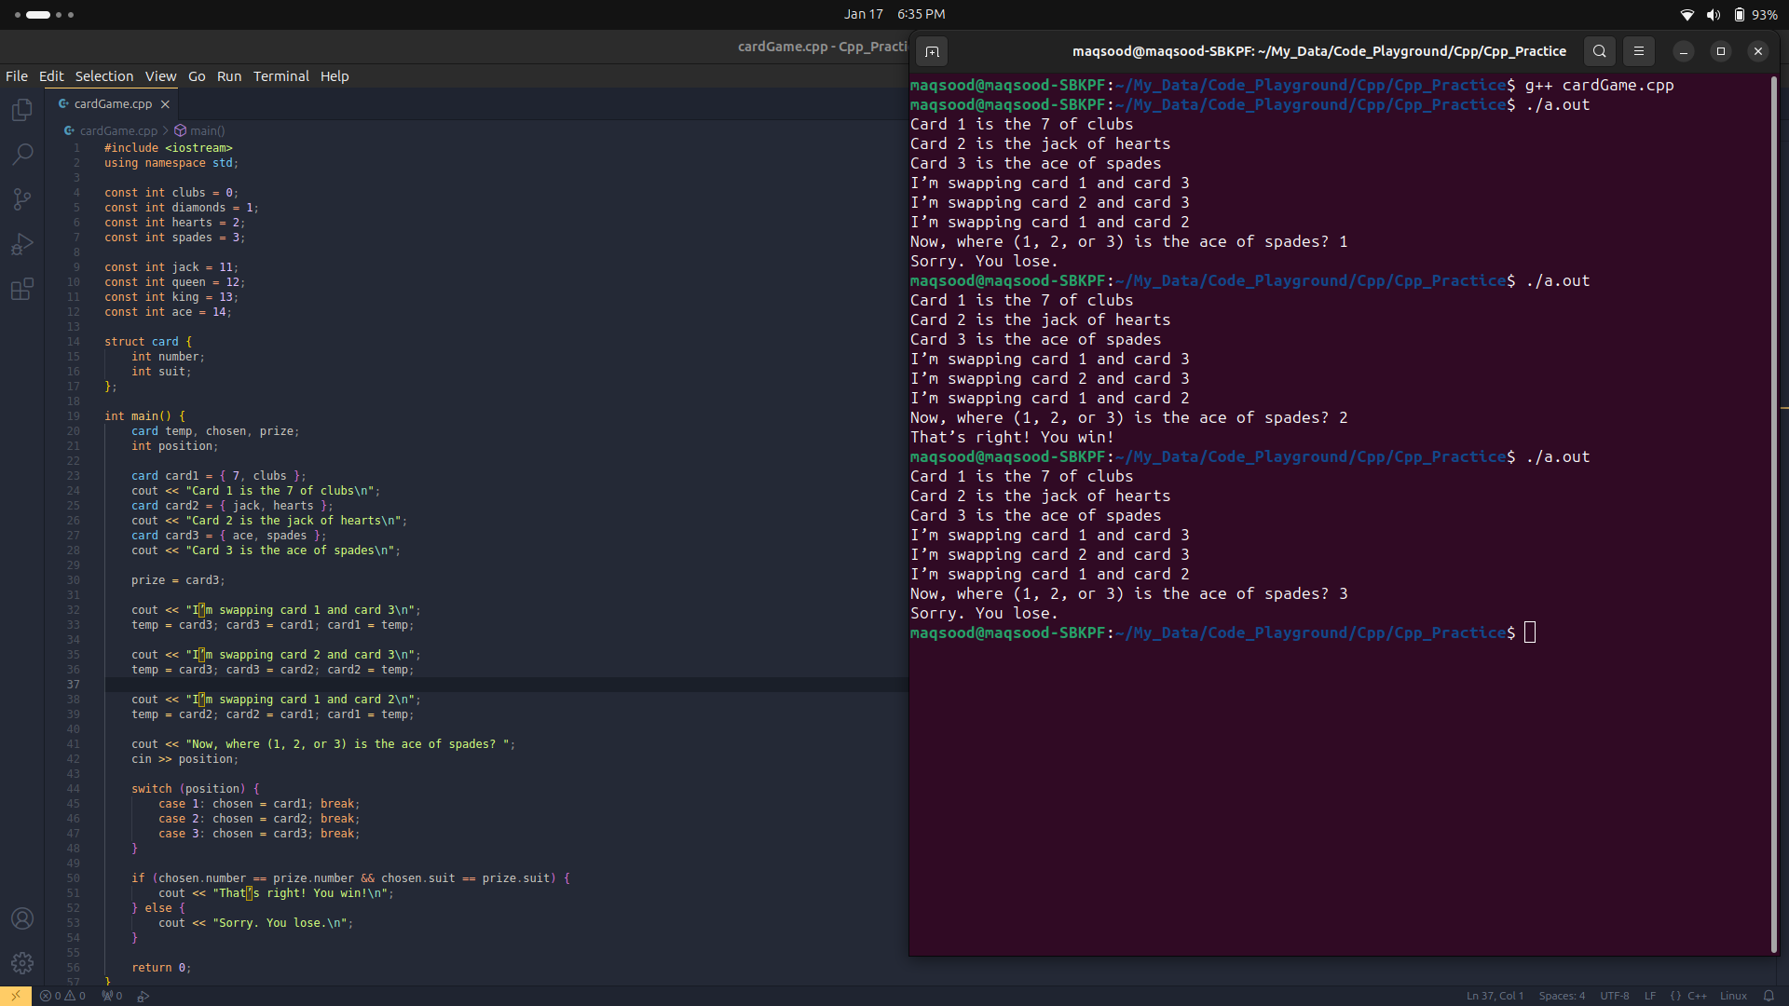

The End

